ASP Area Report Form 2020/2021 REGION: Japan West
Report Date for 2020/21 | 2021/5/12
Name | Hirokazu Furuta
Position | RD Japan West region

Share what you consider to be the achievements/highlights of the Region and the Area
The main goal was to develop stronger public relations activities.
As a result, district and club websites were newly established or renewed.
Many club and district projects were picked up by newspapers and other mass media.

Week4Waste
Many clubs and districts engaged in clean-up campaigns not only during the period of April 18 to 25, but also outside the period.
Among them, Kyoto Toryo Club has been cleaning up the local area and large festivals every month for 17 years since the club was founded.

The following is a table of leadership training sessions held in Japan West Region over the past year.
In addition to this, there are many other leadership training sessions held by each club.

Regional Training sessions held in 2020/21
July 2020 – April 2021
Region : Japan West Training Levels |  | Month/Date
Club Officers | March31,2021 |  | Kyoto To-Be club  In addition to the To-Be club, more than 50 other clubs have also implemented the program.  Use the club’s original program.
Regional Service Directors | November28,29  March6,2021  August5,2020  August27,2020  September18.2020  October1,2020  October9,2020 |  | Training for Regional Service Director elect and District Governor elect .  Use the Region’s original program.  Training for Club President elect and  District Service Director elect.  Training for District Service Director.  Training for District Service Director.  Training for District Service Director.  Training for District Service Director.  Training for District Service Director.  Use the original program.
District Governors | July4,2020  July11,2020  July25,2020 |  | Nishichugoku-District  Setosanin-District  Kyushu-District  Six other sections were also conducted.  Use the original program.
General membership

Business study sessions were introduced as a means of increasing membership, especially among the younger generation, and a method of gaining members through business study sessions was put into practice.

As the effects of the COVID-19 have made it difficult for members to interact with each other in the Japan West Region, an event called the "Japan West Region Forum" was held to provide an opportunity for members to interact with each other.

A special committee was set up to collect funds and provide relief to clubs affected by the GOVID-19.
A special committee was set up to collect funds and provide relief to clubs affected by theCOVID-19, and funds were used to support the cost of a system for each club to conduct remote meetings.

It was decided that the IBC between the Kitakyushu club and the Lumbini club in Nepal will be concluded on May 29, despite the COVID-19.
Membership and Financial Targets & Achievements (as may be applicable)
We now have 1,431 members, an increase of 20 from the beginning of the term.

A table of the increase/decrease in the number of members in each district is on the next page.

 | 2020-21 | Japan West membership report
 | District |  |  | 2020/7/1 |  | IN | OUT | 2021/6/1
 |  |  |  | members |  |  |  | members
 | Chubu |  |  | 89 |  | 2 | 6 |  | 85
 |  |  | 7clubs
 | Biwakobu |  |  | 105 |  | 3 | 14 |  | 94
 |  |  | 7clubs
 | Kyotobu |  |  | 513 |  | 28 | 8 |  | 533
 |  |  | 18clubs
 | Hanwabu |  |  | 103 |  | 11 | 0 |  | 114
 |  |  | 7clubs
 | Chuseibu |  |  | 105 |  | 1 | 5 |  | 101
 |  |  | 7clubs
 | Rokkoubu |  |  | 132 |  | 8 | 0 |  | 140
 |  |  | 8clubs
 | Seto-saninbu |  |  | 47 |  | 3 | 1 |  | 49
 |  |  | 4clubs
 | Nishi-chugokubu |  |  | 65 |  | 1 | 2 |  | 64
 |  |  | 5clubs
 | Kyusyubu |  |  | 252 |  | 5 | 6 |  | 251
 |  |  | 17clubs
 | TOTAL |  |  | 1411 |  | 62 | 42 |  | 1431

Each remittance amount is as follows.
ASF 1,682.23 CHF
EF 1,212.89 CHF
TOF 16,481.62 CHF
BF 15,037.61 CHF
RBM 7,257.37 CHF
PWA Legacy 3,942.72 CHF
Menettes 1,072.98 CHF (Menettes Dues 83.43 CHF Menettes Int Project 955.8CHF)

Outline specific objectives/actions you are proposing for 2021/22
Toward the 100th anniversary of the founding of Y's Men's Club, it is necessary for each member to know himself or herself and change himself or herself in order to restore the vitality of Y's throughout the West Japan District and make the West Japan District full of vitality.

Key Objectives of Activities

1. EMC project
Aim to increase the number of members by 300.
Establishment of new clubs: 2 clubs
Implementation of EMC symposium in each club in the first semester
Conduct orientation for new members in each club. 2.

2. YMCA Service and Youth Programs

2. YMCA Service Youth Project - To deepen the understanding of the YMCA Service Youth Project and strengthen the partnership with the YMCA.

Indicate topics needing Area or International attention | Timeframe  (immediate, within the year, long term, etc.)

Additional Comments, if any
Thank you for all your help and support over the years.
I look forward to working with you again in the future.

The 24th Japan West Region Convention was held on June 5 and 6.
There is a report on the convention on the next page.

The 24th Japan West Region Convention
2021.6.5-20216.6
Venue: Kyoto, Japan

The event was held over two days with a total of about 500 participants, including about 350 on-site and 150 remote participants.
Reports on the year's activities and various awards were presented.
There was also a lot of interaction among the members, which helped to promote friendship.

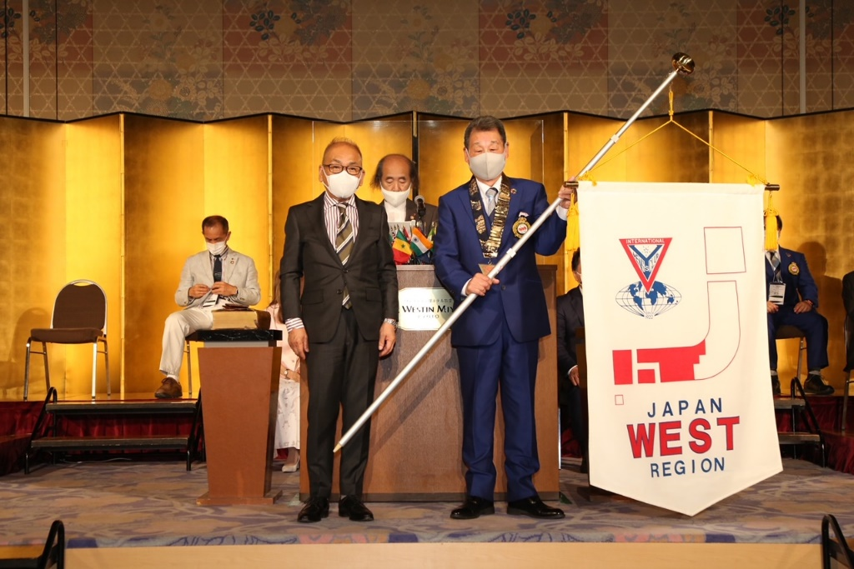

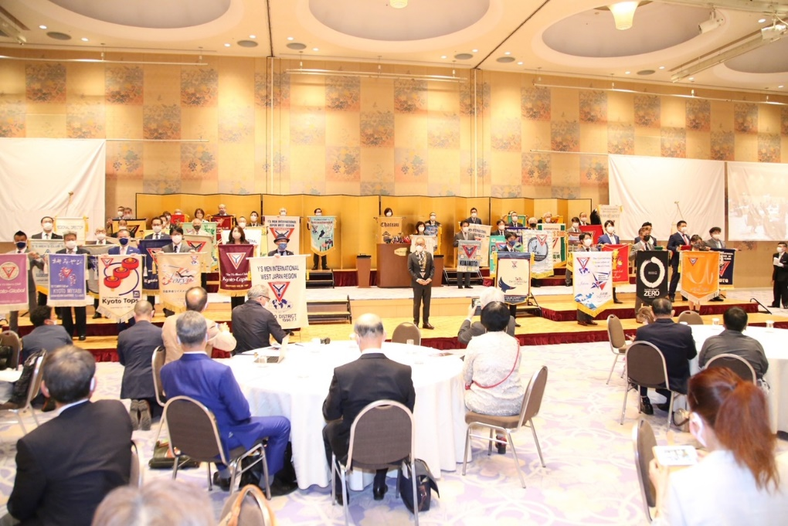
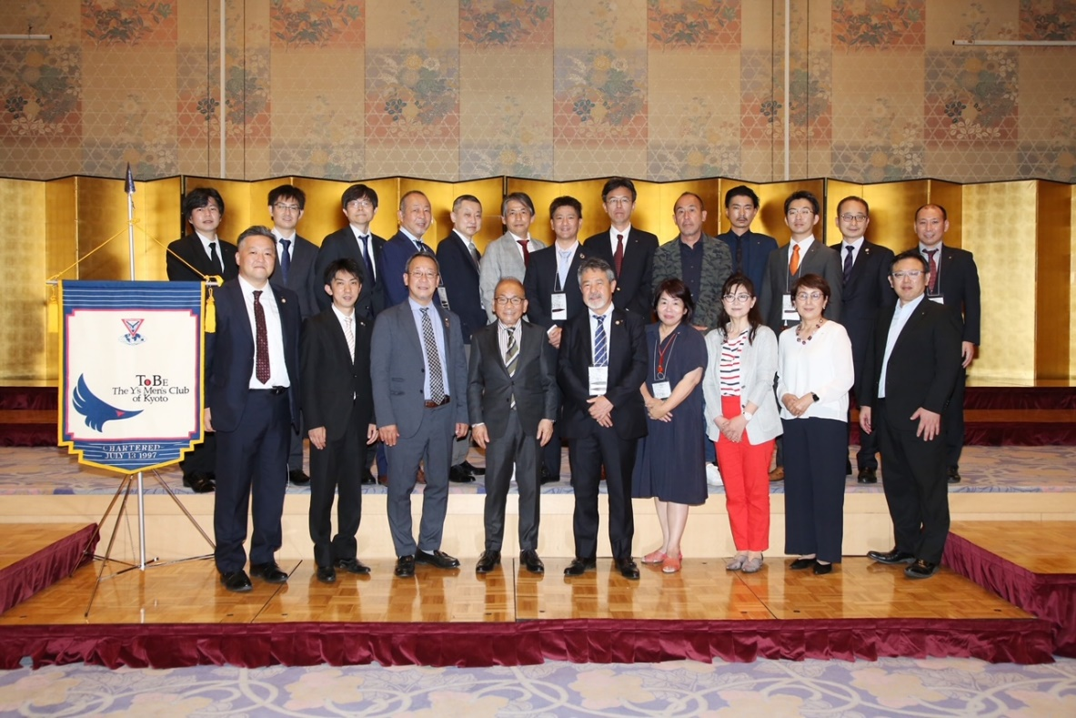
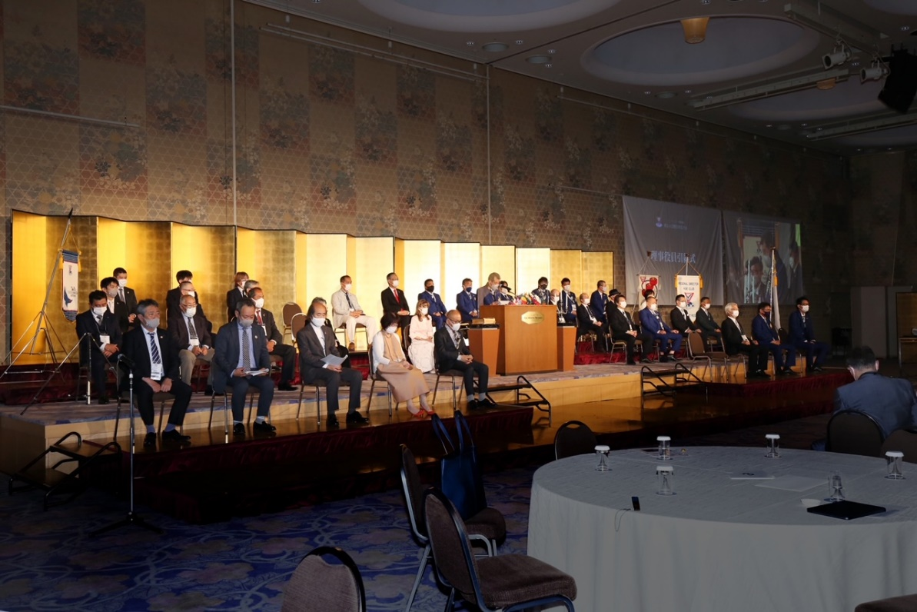

*Motions should not be included in this report. If you would like to submit a motion, please do so using this online form Motion Submission Form which will be submitted directly to the AEOs. Note only well- reasoned motions with sufficient background information and a clear rationale will be considered.

